TITLE

FIRST NAME AND SURNAME, FIRST NAME AND SURNAME ²

ABSTRACT. This section should include the main aim of the paper, the data and methods used as well as the main results and conclusions of the research. It is recommended to not use abbreviation in this section except those generally known (e.g. WMO, GIS etc.). Citations are not allowed in this section.

Keywords (4-6): climate change, hydrological process

1. INTRODUCTION

This section should present the state of the art in the research area (Lakatos et al., 2006) and the declared aim and objectives of the paper. The authors should provide an overview of the already developed study at international level and in the area/region of interest. Citations in the text should be made according the Guidelines for authors.

2. DATA AND METHODS
2.1. Data used
2.1.1. Type of data 1
The authors should describe each type of data and metadata used for the research. They should include the data source and availability, if the case.
Standard abbreviation for units should be used.
2.1.2. Type of data 2

2.2. Methods

In this section the authors should provide all methods they used to get the results. If the methods have already been described in literature, than a short presentation together with sources where detailed information can be found will be provided (Figure 2). If a new method is presented, that all the details should be included so that anyone can reproduce the research based on presented methods.
Equations have to be written by using equation editor and will be numbered consecutively from the first to the last one.
Each type of methods should be presented separately in sub-chapters (e.g. indices calculation, trend detection etc.)
In case that maps are presented as figure, the mapping methods and software used should be mentioned.
If specific software applications are employed to process the data, than they will be mentioned in this chapter, too.

3. RESULTS AND DISCUSSIONS

The results should present the findings of the paper resulted from processing the data by the use of the methods mentioned above, as well as the discussions, explanations of the results in the context of international state-of-the-art (Fig. 1, Table 1).
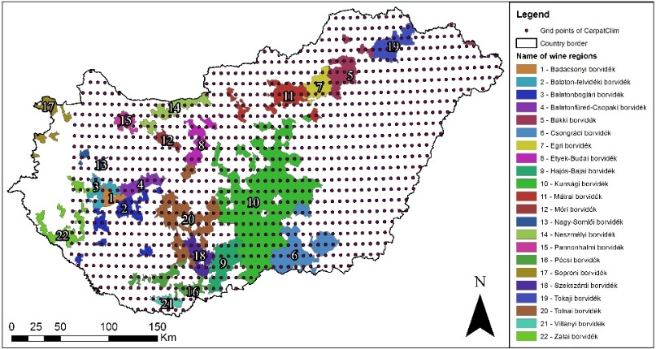
Fig. 1. Concise title of the figure. They will be in colour online and in grey scale in print. The author(s) should provide good quality figures at a minimum resolution of 300 dpi and they have to ensure that the figures in colour are suitable for greyscale printing version (source (if the case)).

Table 1. The timing of air and ground frost in autumn and spring across the Romanian Plain region
Weather station grid cell locations | Autumn |  |  |  |  | Spring
 | FA_{air} | FA_{ground} | FA_{ground} earlier than FA_{air} (days) | FA_{air} earlier than FA_{ground} (days) | FA_{air} = FA_{ground}  (cases) | LS_{air} | LS_{ground} | FA_{ground} earlier than FA_{air} (days) | FA_{air} earlier than FA_{ground} (days) | FA_{air} = FA_{ground}  (cases)
Drobeta Tr. Severin | Nov.3 | Nov.14 | 56 | 42 | 7 | Mar.28 | Mar.14 | 64 | 10 | 2
Calafat | Nov.1 | Nov.15 | 52 | 4 | 6 | Mar.23 | Mar.11 | 49 | 7 | 4
Craiova | Oct.29 | Nov.25 | 57 | 10 | 4 | Apr.1 | Mar.11 | 52 | 9 | 0
Călăraşi | Oct.27 | Nov.27 | 62 | 0 | 1 | Apr.5 | Mar.5 | 79 | 22 | 1
Buzău | Oct.29 | Nov.2 | 62 | 0 | 2 | Apr.2 | Mar.5 | 75 | 0 | 0
Galaţi | Oct.24 | Dec.1 | 60 | 0 | 2 | Apr.5 | Mar.7 | 79 | 0 | 1
Tecuci | Oct.24 | Dec.1 | 70 | 0 | 0 | Apr.5 | Feb.25 | 93 | 0 | 0
Note: FA_{ground} earlier than FA_{air} and FA_{air} earlier than FA_{ground} indicate the maximum delay (days) between the two onsets/offsets; FA_{air} = FA_{ground} represents the number of cases with simultaneous occurrence of frost in the air and on the ground.
Results, results, results, results, results Results, results, results, results, results Results, results, results, results, results Results, results, results, results, results Results, results, results, results, results Results, results, results, results, results Results, results, results, results, results results, results, results results, results, results results, results, results results, results, results results, results, results results, results, results results, results, results results, results, results results, results, results results, results, results results, results, results results, results, results results, results, results results, results, results results, results, results results, results, results results, results, results results, results, results results, results, results results, results, results
Fig. 2. In case of wrapped figures, the title should be in a textbox placed below the figure and they should be grouped.

5. CONCLUSIONS

This section should present not only the summary of the results, but also implication of the results obtained limitation of the study, as well as further development of the research (if the case).

Acknowledgements

The authors should mention the number of the grant in case the research was developed under the framework of the research project, the data sources as well as private persons for specific/technical support (English language, graphical support etc.)

References

- Dunkel Z., Kozma F. (1981), A szőlő téli kritikus hőmérsékleti értékeinek területi eloszlása és gyakorisága Magyarországon. Légkör 26(2), 13–15. (in Hungarian)
- Enete A.A., Amusa T.A. (2010), Challenges of agricultural adaptation to climate change in Nigeria: a synthesis from the literature», field actions science reports [online], URL: http://factsreports.revues.org/678. Accessed on 02.01.2010
- IMAJ (2017), Iran’s Ministry of Agriculture Jihad, Tehran, Iran. www.maj.ir. Accessed on 31.12.2017.
- Micu D.M., Dumitrescu A., Cheval S., Birsan M.V. (2015), Climate of the Romanian Carpathians. Variability and Trends, Springer. Cham, Elveția DOI: 10.1007/978-3-319-02886-6_7.
- Micu D.M., Dumitrescu A., Cheval S., Birsan M.V. (2015), Regional Climatic Patterns, in book Climate of the Romanian Carpathians. Variability and Trends, Springer, Cham, Elveția, DOI: 10.1007/978-3-319-02886-6_7.
- Mustafa A., Van Rompaey A., Cools M., Saadi I., Teller J. (2018), Addressing the determinants of built-up expansion and densification processes at the regional scale. Urban Studies, 55(15), 3279–3298. DOI https://doi.org/10.1177/0042098017749176.
- Shi S., Wall R., Pain K. (2018), Exploring the significance of domestic investment for foreign direct investment in China: A city-network approach. Urban Studies. DOI: https://doi.org/10.1177/0042098018795977.
- World Bank (2011), Integrating a child focus into poverty and social impact analysis. UNICEF – World Bank guidance note. Washington, DC: World Bank. URL: http://go.worldbank.org/OSPTUYMV60. Accessed on 15.12.2017.

Affiliation of the first author, including the contact data (mailing and e-mail addresses)
Affiliation of the second author, including the contact data (mailing and e-mail addresses)

